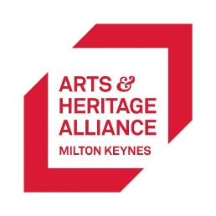

Arts and Heritage Alliance Milton Keynes
ABOUT US
The Arts & Heritage Alliance Milton Keynes promotes, represents and develops arts and heritage, collaboratively delivering and supporting exciting activities. We aim to make the arts and heritage sector more inclusive and diverse, and a safe place to be for everyone. In 2022, we worked with Clare Summerskill to investigate LGBTQ+ cultural practices in Milton Keynes, and with The Stables and Q:Alliance, support her work here this evening.
I’ve Been Clare Summerskill
Saturday 12th November 2022
Feedback Form

What made you come to this event?
- I like to support LGBTQ+ artists and events
- I like to feel part of an LGBTQ+ community
- I came with friends
- It was something to do
- I’m interested in comedy
- I feel safe here
- I’ve come for Clare Summerskill
- I’ve come for Arts and Heritage Alliance MK
- I’ve come for The Stables

How would you rate the following statements from 1-5? 1 = strongly disagree; 5 = strongly agree
- Arts and culture is essential to my life – 1 2 3 4 5
- LGBTQ+ arts and culture is essential to my life – 1 2 3 4 5
- I like to see artists with a track record and proven popularity – 1 2 3 4 5
- I like to go to things that are new/different or that I haven’t seen before – 1 2 3 4 5
- I feel that it is important to create memories with friends and loved ones – 1 2 3 4 5

How did you hear about this event?

What artistic/cultural LGBTQ+ events in Milton Keynes/Bucks have you previously attended?

Would you like to attend a LGBTQ+ history club in Milton Keynes? We are hoping to launch this in the new year.

Are you happy to provide your email address to be contacted about LGBTQ+ history club?

Do you have anything you would like to share about your experience of ‘I’ve Been Clare Summerskill’?

