THE BIG

Registration Form

Personal Details
How are you taking part?
I/We will be participating in The Big Make as a (please tick below)
whole school ☐ | school class ☐ | group ☐ | family ☐ | individual ☐

Please provide a main point of contact indicating their relationship to the participant(s)
* Parental consent is required for all participants under the age of 18
Parent/Guardian ☐ | Family Member ☐ | Group Leader ☐ | Teacher☐ | Participant (18+) *☐

Main Contact | Click here to enter text. | Participant Name* | Click here to enter text.
Contact Email* / Telephone | Click here to enter text. | Participant Age  Year Group  Name of school/group | Click here to enter text.  Click here to enter text.  Click here to enter text.
*If you are participating as a school or group there is no need to provide all participant names. Please include your school name and indicate how many children will be taking part and their year group / age range.

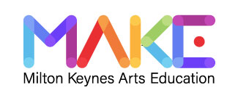
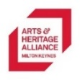
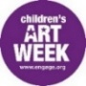
Fundraising Details
Once complete please return this form to: thebigmake@aha-mk.org
The Arts and Heritage Alliance MK manages MAKE. Together we nourish and support the creative and cultural wellbeing of our children and young people. Charity number 1158874. The Big Make is supported by Engage.

I/We will be: (please tick below)
making and selling ☐ | doing a sponsored make ☐ | making a donation ☐ | taking part just for fun ☐
All money raised will directly fund arts projects which support and nourish the creative and cultural wellbeing of MK’s children and young people. Joining the fundraiser is not compulsory.
I’m raising money as part of

helping children & young people’s cultural wellbeing
THE BIG

Name:Click here to enter text.

My Big Make:Click here to enter text.

When:Click here to enter text.

Where:Click here to enter text.

All money I raise will go to MAKE, a charitable initiative which supports the creative and cultural wellbeing of children & young people in Milton Keynes.

Full name | Date | Donation / sponsorship amount: | Money received?
Click here to enter text. | Enter a date. | £ 0 | ☐
Click here to enter text. | Enter a date. | £ 0 | ☐
Click here to enter text. | Enter a date. | £ 0 | ☐
Click here to enter text. | Enter a date. | £ 0 | ☐
Click here to enter text. | Enter a date. | £ 0 | ☐
Click here to enter text. | Enter a date. | £ 0 | ☐
Click here to enter text. | Enter a date. | £ 0 | ☐
Click here to enter text. | Enter a date. | £ 0 | ☐
Click here to enter text. | Enter a date. | £ 0 | ☐
Click here to enter text. | Enter a date. | £ 0 | ☐
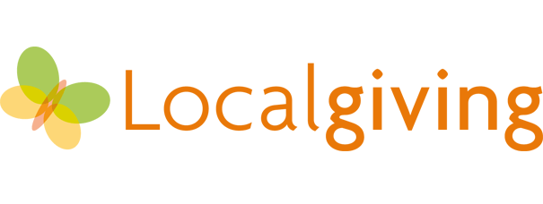
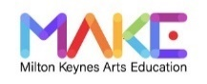
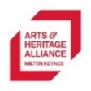
0
www.localgiving.org/appeal/thebigmake

www.aha-mk.org/the-big-make
Participants under the age of 18 must have permission from a parent or guardian to take part in The Big Make or fundraise for MAKE. MAKE is not responsible for the organisation of participants’ Big Make activity or for the collection of money.

AHA-MK is the
lead charity organisation for MAKE. Charity number 1158874

TOTAL RAISED £
How to pay in
Pay in your donation/sponsorship money safely and easily online using Local Giving. Visit:

